**// STRING BASED TASK – 8 //**

Q1. Write a program to check if the letter ‘e’ is present in

the word ‘Umbrella.’.

Enter Any String: Umbrella

e is Present in the word :YES

// SOURCE CODE

import java.util.Scanner;

public class CheckLetter {

public static void main(String[] args) {

Scanner scanner = new Scanner(System.in);

System.out.print("Enter Any String: ");

String input = scanner.nextLine();

if (input.contains("e")) {

System.out.println("e is Present in the word :YES");

} else {

System.out.println("e is not Present in the word :NO");

}

}

}

// OUTPUT:

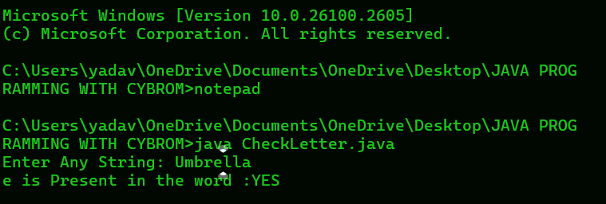

Q2. Write a program to check if the word orange is

present in the &quot;This is orange juice&quot;.

Enter Any String: This is orange juice

orange is Present in the Sentence :YES

// SOURCE CODE

import java.util.Scanner;

public class CheckWord {

public static void main(String[] args) {

Scanner scanner = new Scanner(System.in);

System.out.print("Enter Any String: ");

String input = scanner.nextLine();

if (input.contains("orange")) {

System.out.println("orange is Present in the Sentence :YES");

} else {

System.out.println("orange is not Present in the Sentence :NO");

}

}

}

